Reports

This document will show you how to add a new Report into jBilling. You may already know that reports are done using Jasper Reports. Remember that you can use iReports as a User Interface to make all the changes you may need. Additional information on this topic will not be covered in this tutorial. This document assumes that you already have your *jrxml* file with your **NEW** report design.

By following an example from beginning to end, you will learn how to add a new report. This report will show the quantity purchased for every product in a selected range by all customers. To filter the results, the report will have two parameters where a user can select date ranges. To make the report more complete, we are also going to add a new report type to jBilling that is going to be called *product*.

In order to tell jBilling that there is a new report you need to follow these steps:

1. Place the report file in a specific folder
2. Run a grails command to compile the *jrxml* file and get a *jasper one*
3. Create a new gsp template
4. Run some DB queries
5. Internationalize the report’s title

# Place the report file in the correct folder

Once you have your *jrxml* file, you need to put it in the following path (in our example the file is going to be called *total\_purchased\_per\_customer.jrxml*):

*{jbilling\_folder}/descriptors/reports/product*

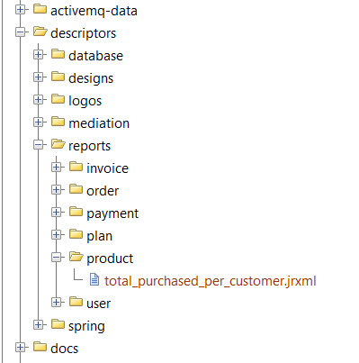

# Run grails command to compile the report file

Once the file is in the correct folder, you need to run a grails command to compile the file. This command will use the jasper report library to compile the *jrxml* file. The result will be a *jasper* file that is going to be used by the application.

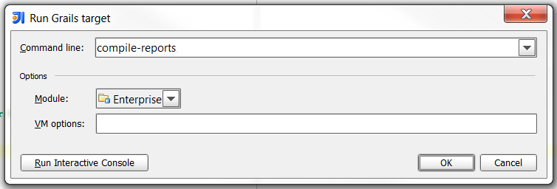

This will copy the compiled file to the */resources/reports/product* folder.

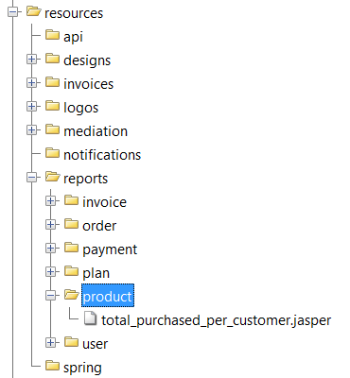

# Create a new gsp template

When you want to use a report you need to select it and then, if required, fill in the parameters. The screen that you see below is a grails template that contains all that information. Therefore, you need to create a new template for your custom report.

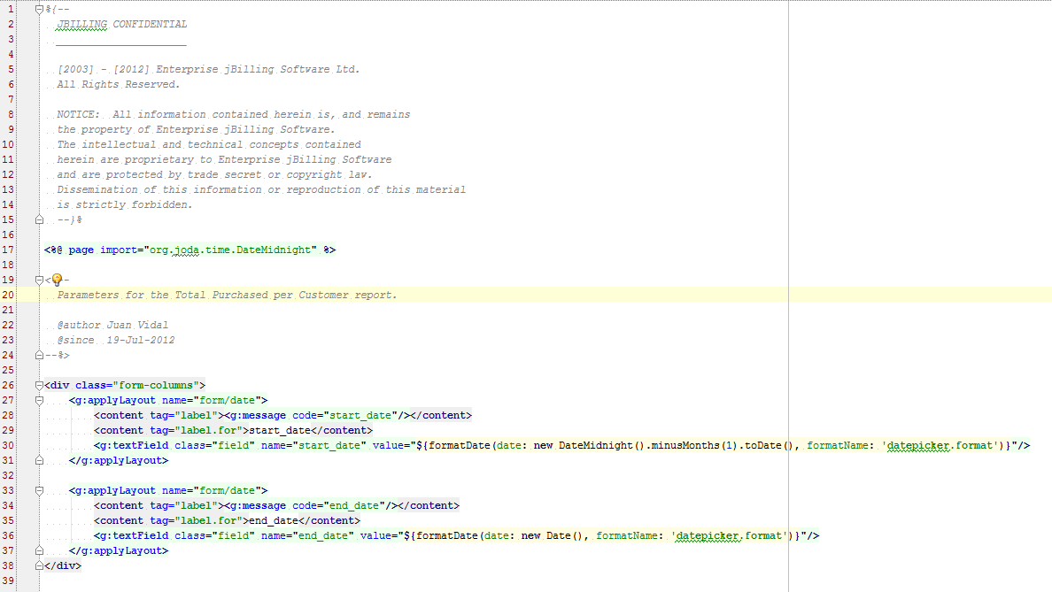

To create this template you can always go back and review the ones that already exist because they are the same. Just copy and paste the elements that you need for your specific case. Once you finish this, you need to put the file in a specific folder. Inside the *grails-app/views/* look for *report* and you should have a folder for the category of your report. In our case, as we are also creating a new category, you need to create a folder called *product*.

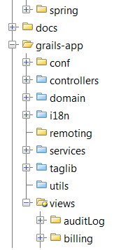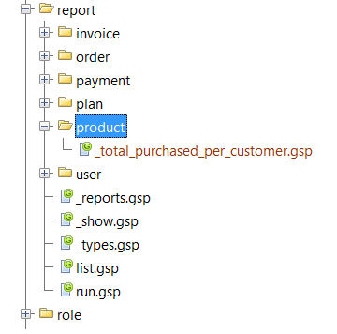

Note: As you know, you can have reports with and without parameters. For our example we are creating one with parameters. If you want to make one without, the template should always look like this:

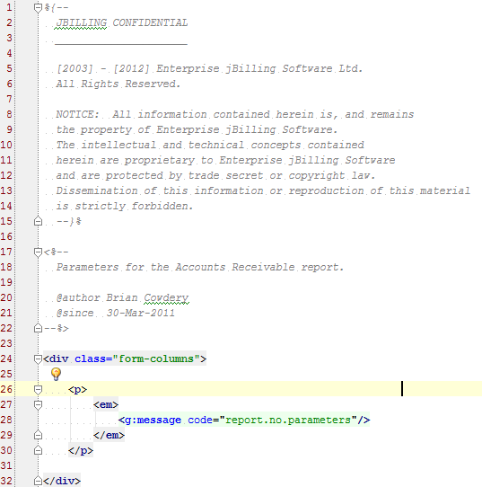

# Run some DB queries

# Up to this point, you have created the template and also the report design. What you need to do now is run some DB queries so that jBilling is aware of this new report.

* Add the new report type to the system.

**insert** **into** report\_type **(**id**,** name**,** optlock**)** **values** **(**6**,** 'product'**,** 0**);**

* Add the new report.

**insert** **into** report **(**id**,** type\_id**,** name**,** **file\_name,** optlock**)** **values** **(**13**,** 6**,** 'total\_purchased\_per\_customer'**,** 'total\_purchased\_per\_customer.jasper'**,** 0**);**

* Add the report parameters. (These queries shouldn’t be run when you are creating a report without parameters)

**insert** **into** report\_parameter **(**id**,** report\_id**,** dtype**,** name**)** **values** **(**22**,** 13**,** 'date'**,** 'start\_date'**);**

**insert** **into** report\_parameter **(**id**,** report\_id**,** dtype**,** name**)** **values** **(**23**,** 13**,** 'date'**,** 'end\_date'**);**

* Add some internationalization in the international\_description table.

This is the description shown when you click on the report inside a category.

**insert** **into** international\_description **(**table\_id**,** foreign\_id**,** psudo\_column**,** language\_id**,** content**)** **values** **(**100**,** 13**,** 'description'**,** 1**,** 'Total purchased by customer on a given period.'**);**

This is the title for the report category.

**insert** **into** international\_description **(**table\_id**,** foreign\_id**,** psudo\_column**,** language\_id**,** content**)** **values** **(**101**,** 6**,** 'description'**,** 1**,** 'Product Reports'**);**

* Relate the report with a company (Entity).

**insert** **into** entity\_report\_map **(**report\_id**,** entity\_id**)** **values** **(**13**,** 1**);**

# Internationalize the report’s title

Finally, you need to add one line to the *message.properties* file to internationalize the report’s title. In this example, it is the last line: *total\_purchased\_per\_customer*.

# C:\Users\jmvidal\Desktop\message_properties.png

# Test the new report

Now that you have completed every step, you will want to test your report, and also see how the new report design looks in the User Interface. To do this you need to click on the Reports section in jBilling’s menu.

C:\Users\jmvidal\Desktop\menu_reports.pngYou will see a list of report types or categories. Click on the new category you have created, *Product Reports (*remember that this title was added in the *message.properties* file*).*

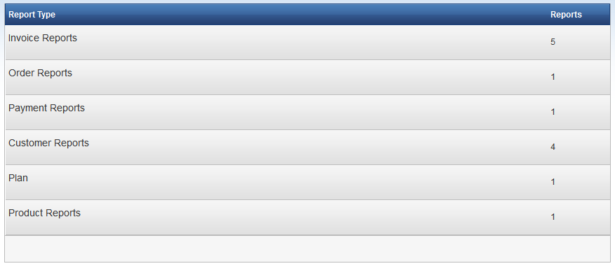

Like all report categories, you will see a list of reports that belong to it.

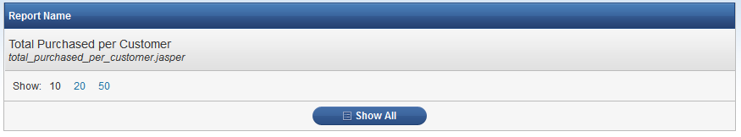

To generate the report, select it to view the configuration screen. This screen is the template that you created in step 3*.* From here you will be able to indicate a date range as well as select the output format: *HTML, PDF or Excel*.

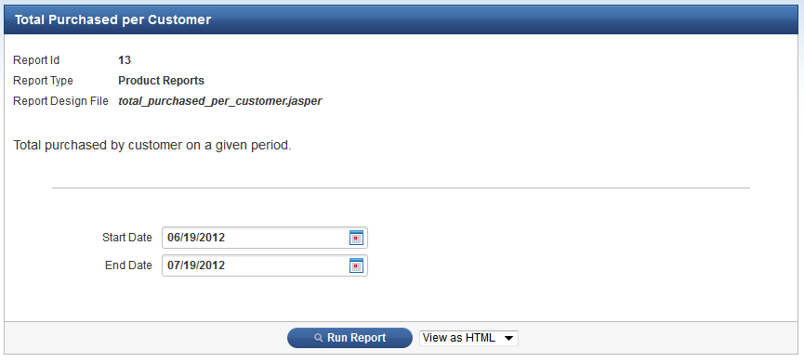

Once you are done configuring the report, click on the Run Report button. If you select HTML you will see the result in a new tab in your browser. If you select PDF or Excel you will get a download popup window. Here are examples of what the HTML and PDF reports will look like:

html report

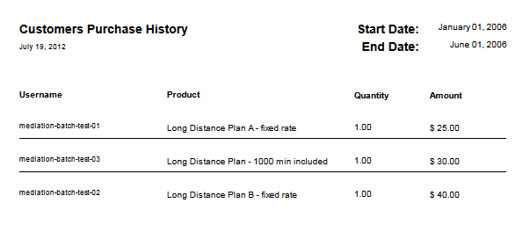

pdf report

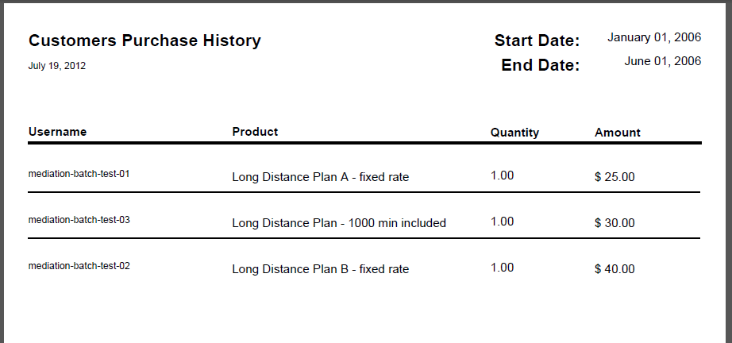

Summary

Here is a summary of all the files that were modified/created in order to complete this exercise.

|  |  |  |
| --- | --- | --- |
| File | Updated or Created? | Description |
| *descriptors/reports/product/* | Created | New product folder for the new report category. |
| *descriptors/reports/product/total\_purchased\_per\_customer.jrxml* | Created | Jasper Report report design file. |
| *grails-app/views/report/product/* | Created | New folder for the new category templates. |
| *grails-app/views/report/product/\_ total\_purchased\_per\_customer.gsp* | Created | Report template. |
| *grails-app/i18n/messages.properties* | Updated | Added one line with the i18n for the Price Models drop down. |